Title or Task: |   

Description:

Files Required
Suitable for Classes: | AIT • Multimedia • Cert II IT • Cert II Bus
Area: | Technology & Enterprise
Teacher: | Mr Peter Faulks

Timeline

Date Due:
Task Brief: | In class lesson

Outcomes:

Solutions

See completed page

http://peterfaulks.net/Teaching/Student_Compendium/SC021_Marriage.htm

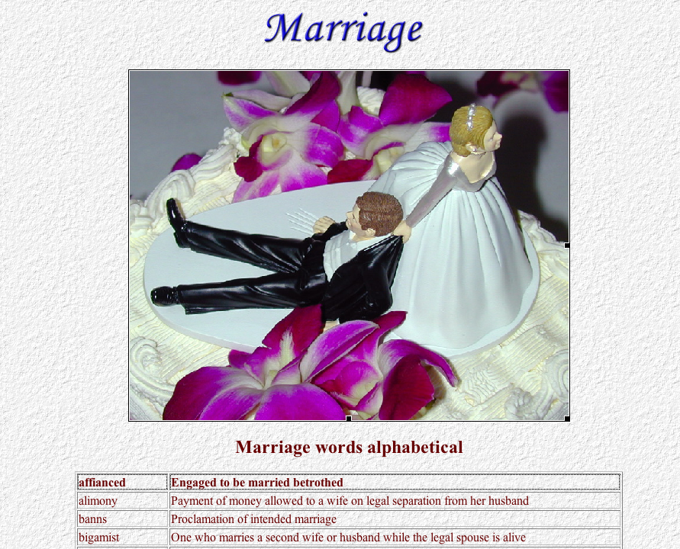

Pertaining to Marriage
One who has only one wife or husband at a time | monogamist
One who marries a second wife or husband while the legal spouse is alive | bigamist
One who has more than one wife or husband at a time | polygamist
A hater of marriage | misogamist
One vowed to a single or unmarried life | celibate
Legal dissolution of the marriage of husband and wife | divorce
Payment of money allowed to a wife on legal separation from her husband | alimony
A man whose wife is dead | widower
A woman whose husband is dead | widow
A child whose parents are dead | orphan
The property which a wife brings to her husband on marriage | dowry
One engaged to be married | fiance, fiancee
Engaged to be married | betrothed, affianced
A bride's outfit | trousseau
Proclamation of intended marriage | banns
To run away with a lover in order to get married secretly | elope



